Attachment B

Request Access to an Agency
Public Portal users will not have access to any agency-specific information without prior authorization from the Property Tax Division.
- From "What would you like to do?" select “My Agencies/Subagencies”.
- Click "Add another subagency" and then "Request access to existing agency/subagency".
  - The first time you log in to the portal, you will not yet have any access.
- Choose the agency/subagency to request.
  - Add a note if desired. This is included in the information the County will review.
  - Click "Submit".
- Click "Add another subagency" and complete the request process as many times as needed to access all the subagencies needed.
Note: The submitted requests will be received by the Property Tax Division. That division will set the appropriate permission level for each request. Permission levels include:
- Read/Write - allows the user to upload annual Direct Charges
- Read-Only - allows the user access to Portal reports No Access - user is denied access to the agency
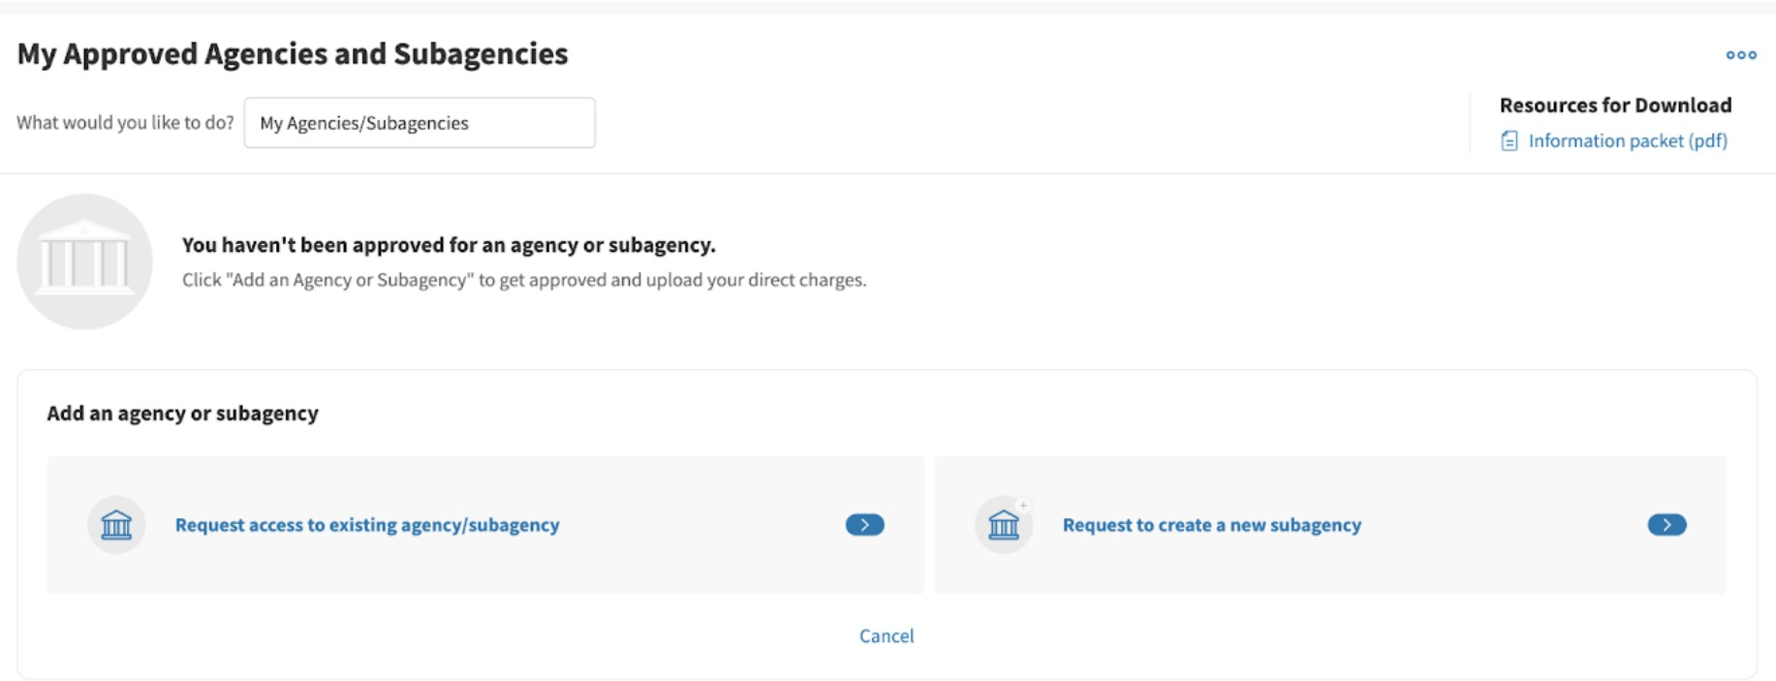
- No Access - user is denied access to the agency



